Ideation Phase Empathize & Discover

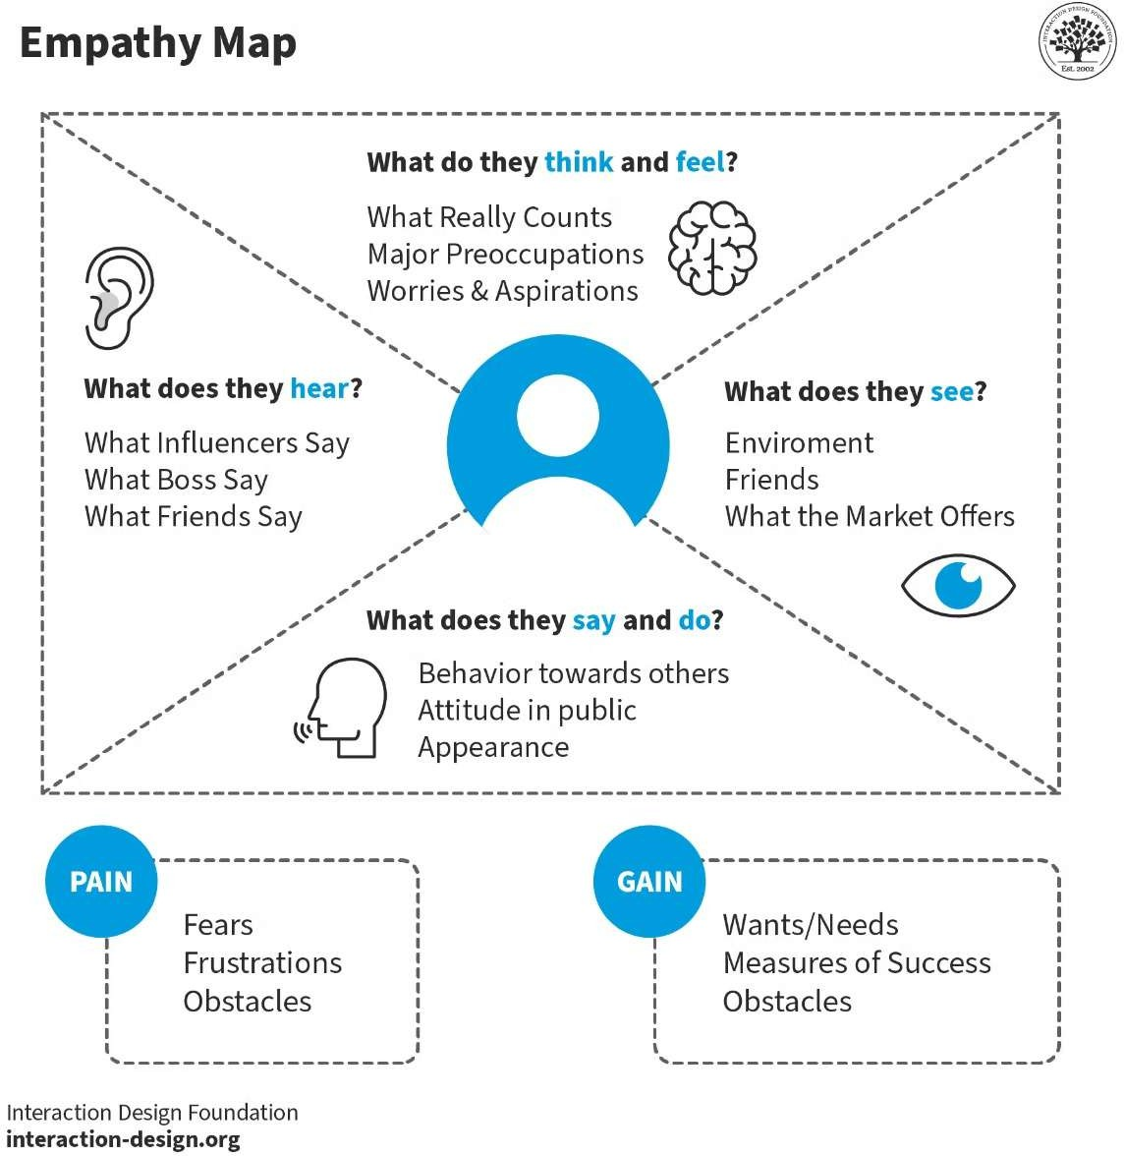

|  |  |
| --- | --- |
| Date | 20 June 2025 |
| Team ID | LTVIP2025TMID31897 |
| Project Name | EduTutor AI: Personalized Learning with  Generative AI and LMS |
| Maximum Marks | 4 Marks |

**Empathy Map Canvas:**

An empathy map is a simple, easy-to-digest visual that captures knowledge about a user’s behaviours and attitudes.

It is a useful tool to helps teams better understand their users.

Creating an effective solution requires understanding the true problem and the person who is experiencing it. The exercise of creating the map helps participants consider things from the user’s perspective along with his or her goals and challenges.

# Example:

**Example: High School Student (Grades 6–12) using EduTutor AI to learn and self-test academic topics.**

🗣 SAYS

* I need help with this topic, but I can’t ask my teacher now.
* Can I get some practice questions for revision?
* I want simple explanations that I can understand.

💭 THINKS

* I wish I could study at my own pace with better tools.
* Exams are coming, but I don’t know if I’m prepared.
* Online materials are too long or hard to understand.

🧍 DOES

* Searches YouTube or Google for topic explanations
* Asks friends or seniors for notes
* Revises from class notes and PDFs
* Avoids quizzes due to lack of confidence

❤ FEELS

* Frustrated by lack of instant, simple answers
* Stressed about incomplete preparation
* Uncertain about progress and exam readiness
* Relieved when guided or tested effectively

🎯 Goals:

* Understand difficult topics quickly and clearly
* Practice with quizzes that are directly related to what they’re studying
* Track what they've learned and what needs review

Ị Pains:

* No personalized learning or one-on-one explanation
* Difficulty in self-assessing knowledge
* Inconsistent access to good learning resources